Imagine it is 1793, you are in Philadelphia, and the Yellow Fever has just been announced as being in your town. You are a young journalist and it is your job to make sure people know what is happening in your town.
Directions:
- Create your own newsletter (back then they were called Gazettes – usually it was a few pages about all the things happening in the town. So the Gazette should have some sort of name like “The Woodchopper’s Gazette”)

- This newsletter must be realistic to the time period. (Meaning it must look like it is 1793 – not 2014. They did not have bleach then, so the paper would not be white.)

- It needs to be the front and back of a piece of paper. (They were larger than our paper today – so it needs to be a larger than the piece of paper then we use today.)

- You must have at least 15 facts among your articles that come from the book An American Plague. (Facts do not mean “24% of people died…” It can be any line from the book that is relevant to the article.)

- Needs to have at least five stories. (These five stories are based on the 15 facts you get from the book. So you might use two facts in one story, three in the next, three in another one, and two in the last one. You just can’t use all of the facts in one article. They must be realistic to the story and what is going on.)

- When including photos you must cite where you got them (ex: An American Plague. Murphy – this would go underneath the photo. Hint: most newspapers have photos – it makes it more interesting to the reader.)

- This must be your OWN creation – it is not a group effort.

- Be creative – this is your time to shine!
Here are some examples of old Gazettes.
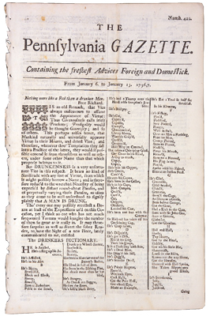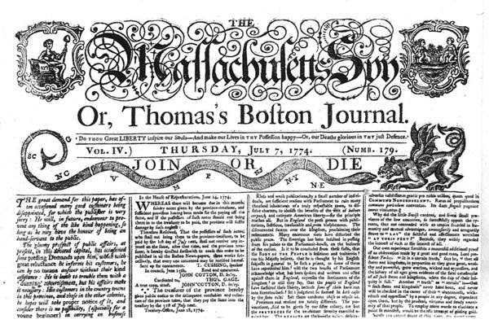

Along the way, you will have things due to help make sure you keep on track. Your first assignment due is your first Article. It will be due this Friday, September 14th. Meaning you are to write your first article on a topic from the book and highlight the facts you use – it needs to be in your homework section of your OneNote labeled, “Article #1 AP.”

Entire project due on Friday, September 28th

